Program 1:

#include<iostream>

#include<fstream>

using namespace std;

int main()

{

ofstream fout("File_1"); //constructor to open file

//fout.open("File_1");

int element,i,j,temp;

cout<<"Enter integer elements of files 1: ";

for(i=1;i<=5;i++)

{

cin>>element;

fout<<element<<" ";

}

fout.close();

fout.open("File_2"); //open() to open file

cout<<"Enter integer elements of files 2: ";

for(i=1;i<=3;i++)

{

cin>>element;

fout<<element<<" ";

}

fout.close();

ifstream fin;

fin.open("File_1");

int arr[8];

i=0;

while(!fin.eof())

{

fin>>arr[i];

fin.get();

i++;

}

i--;

fin.close();

fin.open("File_2");

while(!fin.eof())

{

fin>>arr[i];

fin.get();

i++;

}

for(i=0;i<8;i++)

{

for(j=i+1;j<8;j++)

{

if(arr[i]>arr[j])

{

temp=arr[i];

arr[i]=arr[j];

arr[j]=temp;

}

}

}

fout.open("File_3");

fout<<"Sorted Merged Data: ";

cout<<endl<<"Contents of File 3: ";

for(i=0;i<8;i++)

{

fout<<arr[i]<<" ";

cout<<arr[i]<<" ";

}

}

Output:

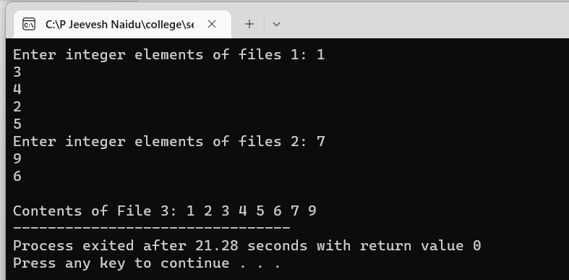

Program 2:

#include<iostream>

#include<iomanip>

#include<fstream>

#include<string>

using namespace std;

class telephone

{

public:

int number;

string name;

void getdata()

{

cout<<"Enter name: ";

getline(cin,name);

cout<<"Enter number: ";

cin>>number;

}

void display()

{

cout<<"Name : "<<name<<"Number : "<<number<<endl;

}

};

void search(int n, telephone t[])

{

string s;

cin.ignore();

cout<<"Enter name to Search: ";

getline(cin,s);

ifstream fin;

fin.open("Telephone Directory.txt");

int i;

for(i=0;i<n;i++)

{

fin>>t[i].name>>t[i].number;

if(t[i].name==s)

{

cout<<"Name : "<<t[i].name<<"\t Number: "<<t[i].number<<endl;

break;

}

}

if(i==n)

cout<<"Not present\n";

}

void update(int n,telephone t[])

{

string s;

cin.ignore();

cout<<"Enter name to Update Details: ";

getline(cin,s);

ifstream fin;

fin.open("Telephone Directory.txt");

int i;

for(i=0;i<n;i++)

{

fin>>t[i].name>>t[i].number;

if(t[i].name==s)

{

cout<<"Enter new number to update: ";

cin>>t[i].number;

break;

}

}

if(i==n)

cout<<"Not present\n";

fin.close();

ofstream fout;

fout.open("Telephone Directory.txt");

for(i=0;i<n;i++)

fout<<setw(15)<<t[i].name<<setw(10)<<t[i].number<<endl;

fout.close();

}

int main()

{

int n;

cout<<"Enter number of contacts in the Telephone Directory: ";

cin>>n;

telephone t[n];

ofstream fout;

fout.open("Telephone Directory.txt");

for(int i=0;i<n;i++)

{

cin.ignore();

t[i].getdata();

fout<<setw(15)<<t[i].name<<setw(10)<<t[i].number<<endl;

}

fout.close();

int ch;

do

{

cout<<"\n1.Search\n2.Update number\n3.Exit\n";

cin>>ch;

switch(ch)

{

case 1:search(n,t);break;

case 2:update(n,t);break;

case 3:break;

default:cout<<"Invalid input.\n";

}

}while(ch!=3);

return 0;

}

Output:

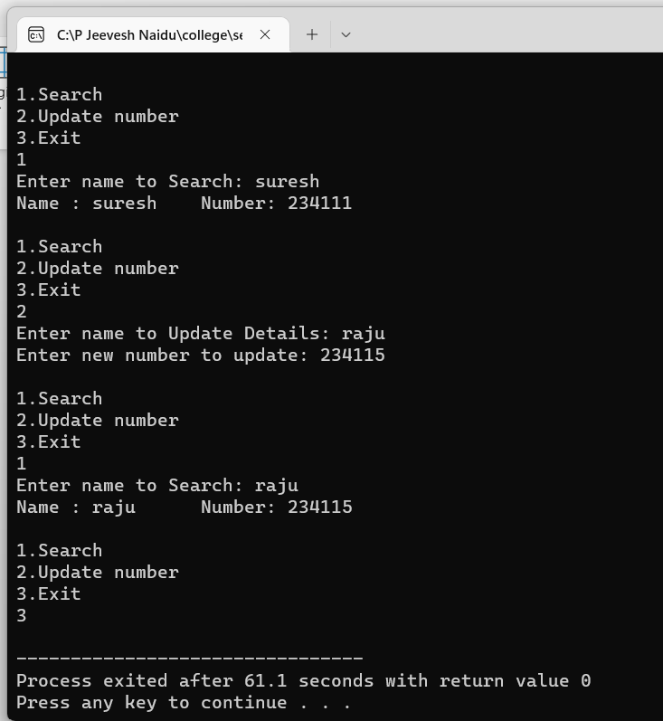

Program 3:

#include<iostream>

#include<fstream>

using namespace std;

class student

{

char name[50];

char address[50];

char branch[50];

int rollno;

public:

char * getname()

{

return name;

}

void getdata(void);

void putdata(void);

};

void student::getdata(void)

{

fflush(stdin);

cout<<"\nEnter name : ";gets(name);

fflush(stdin);

cout<<"Enter roll no : ";cin>>rollno;

fflush(stdin);

cout<<"Enter Address : ";gets(address);

fflush(stdin);

cout<<"Enter branch : ";gets(branch);

}

void student::putdata(void)

{

cout<<"NAME : "<<name<<" ";

cout<<"ROLLNO : "<<rollno<<" ";

cout<<"ADDRESS : "<<address<<" ";

cout<<"BRANCH : "<<branch<<endl;

}

int main()

{

int choice;

student stud;

while(1)

{

cout<<"\n";

cout.fill('-');

cout.width(35);cout<<"Menu";cout.width(30);cout<<"-";

cout<<"\n1.Add the entry ";

cout<<"\n2.Search ";

cout<<"\n3.update the entry";

cout<<"\n4.Quit";

fflush(stdin);

cout<<"\nchoose from menu : ";

cin>>choice;

switch(choice)

{

case 1:

{

cout<<"\n";cout.width(35);cout<<"ADD THE ENTRY";cout.width(30);cout<<"-";

stud.getdata();

ofstream file(stud.getname());

file.write((char *)&stud, sizeof(stud));

break;

}

case 2:

{

cout<<"\n";cout.width(35);cout<<"SEARCH";cout.width(30);cout<<"-";

char n[30];

cout<<"\nEnter name to search : ";

fflush(stdin);

gets(n);

ifstream file(n);

if(file.good())

{

file.read((char *)&stud,sizeof(stud));

stud.putdata();

}

else

cout<<"\n"<<n<<" student is not there in record";

break;

}

case 3:

{

fflush(stdin);

cout<<"\n";cout.width(35);cout<<"UPDATE";cout.width(30);cout<<"-";

cout<<"\nEnter name of student to be updated : ";

char n[50];

fflush(stdin);

gets(n);

ofstream file(n,ios::trunc);

if(file.good())

{

cout<<"Enter new data";

stud.getdata();

file.write((char *)&stud,sizeof(stud))<<flush;

rename(n,stud.getname());

}

else

cout<<"\n"<<n<<" student is not there in record";

break;

}

case 4:

{

exit(1);

}

default:

{

cout<<"\ninvalid choice ";

break;

}

}

}

return 0;

}

Ouput:

